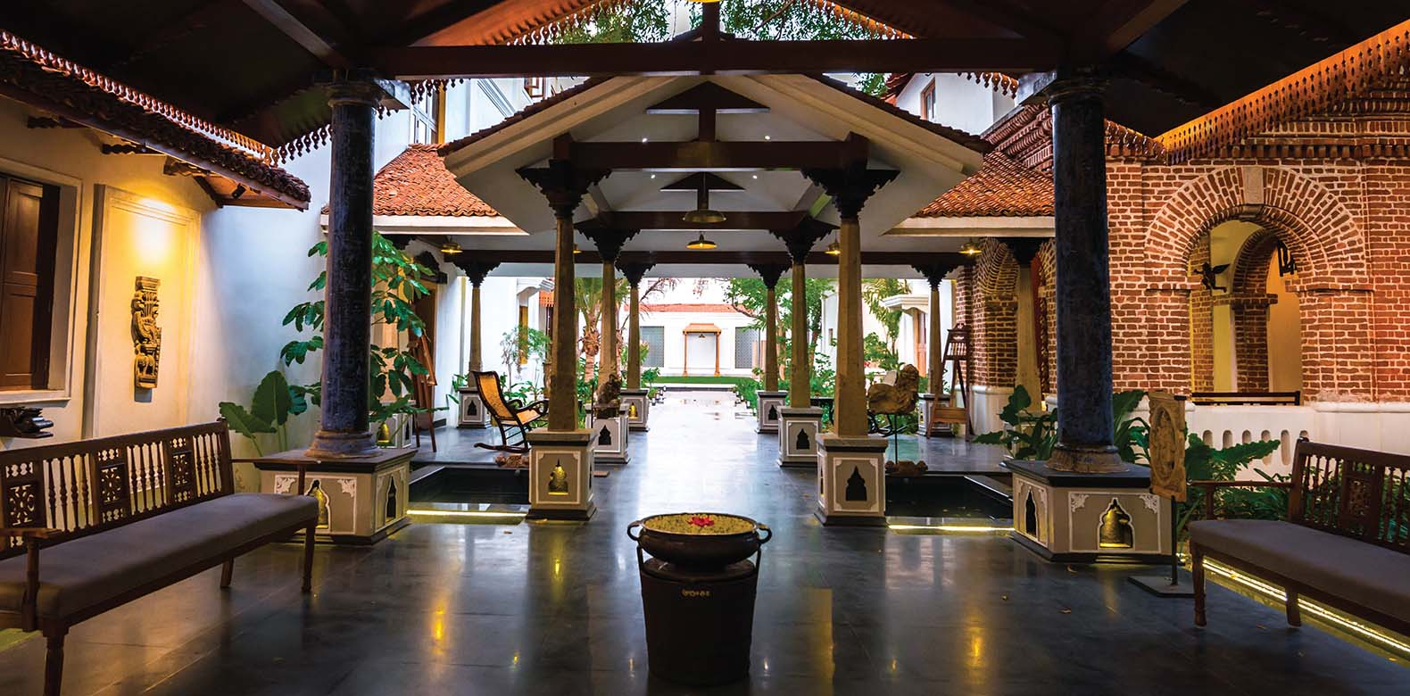

15 destinations, 15 unique experiences: Relais Chateaux India, Sri Lanka, Maldives
Svatma Heritage Residence Thanjavur Fact File

Hotel Address
Svatma, No. 4/1116, Blake Hr Sec School Road, Maharnonbu Chavadi, Maharnonbu Chavadi, Thanjavur, Tamil Nadu 613001
info@svatma.in |res@svatma.in| www.svatma.in

Location
Svatma Heritage Residence Thanjavur, city that dates back to 4th AD in the South Indian state of Tamil Nadu
5 minutes’ away from Railway station, and 55 minutes from the nearest Airport (Trichy International Airport)

GPS
Latitude: 10.781282; Longitude: 79.1464073

Accessibility
By air Trichy International airport gets daily flights from Chennai, Colombo, Singapore, Kuala Lumpur and Bangkok
International flights connecting from all major global metros via Trivandrum, Calicut, Bangalore, Hyderabad, Chennai,
By train Thanjavur Railway Station connected to all major cities in India, and Kerala.
By road Thanjavur connected with major National Highways in Tamilnadu NH67, NH45C and NH226

Transfer
Svatma arranges our own Vehicle to transfers Guest from the airport & railway station. Time to airport is 45 minutes for 50 Km, to station 10 minutes, 1.5 Km.

The Hotel
With origins dating back to 4AD, Thanjavur in the South Indian state of Tamil Nadu has a 1000-year-old, exquisitely carved Brihadeeswarar temple that is a UNESCO world heritage site. ​Not far from the imposing monument is Svatma, which opened in 2015 as a boutique hotel after a decade of painstaking restoration of a 150-year-old home. Decorated with traditional art and ornate furniture, Svatma offers seven lovingly restored rooms and suites in the heritage wing complemented by a new 30-room millennium wing.
Svatma Restaurants & Bar,
Svatma is proudly vegetarian and serve a well balanced meals that includes local fare and continental cuisine
Aaharam: The culinary expertise of home style pure vegetarian cooking is brought to the guest as an art form. The restaurant Aharam is an all-day fine food restaurant with a traditional display kitchen that overlooks the pool. It has a unique menu - an exploration of Tamil cuisine available a la carte in an exclusive bouquet of plated mini meals. Ideal for health conscious foodies wanting to explore the flavours of the region, the ingredients are organic and carefully prepared by trained specialist chefs.

Palaharam is a joyful affair of coffee and tiffin in the veranda. The special hand-poured filter coffee, traditional health drinks and gourmet ethnic snacks presented in a quirky fashion make it a most memorable hangout.

Nila roof top bar with stars as your Canopy enjoy our selection of Beverage, Wine & Cocktails.
We are committed to the Relais & Chateaux vision of a cuisine that is representative of local culinary culture and environment. We use the best of local produce and prefer organic products wherever possible.

Facilities

There are two wings with 38 Luxury Heritage Rooms, Divyam the Banquet Halls with Colonial Ambience - Capacity: 250 People, Two Restaurants and a Bar with Unique Menus, Spa, Swaram Sounds Spa ,Gym and Yoga Centre, All 38 rooms are air-conditioned with attached bathrooms. The rooms are decorated with stunning color schemes, antique & contemporary objects d’art. All rooms have air-condition, shower facilities, hanging space, televisions, direct dial telephones, WIFI, safe deposit lockers, coffee makers and minibar. All Rooms are Non Smoking | Differently able Room are available | Front desk opened and staffed 24/7.

AROGYAM & SOUKYAM

Arogyam the Gym and Yoga centre is staffed with experienced tutors who can guide the body to a path of fitness using traditional asanas and simple meditative practices. Soukyam, the luxury spa has four private full body massage/treatment rooms as well as a relaxation area for foot and shoulder massages.

The staffs are trained therapists attuned to luxury travelers requiring customized treatment plans under expert advice by a wellness consultant. Long stay wellness packages are tailor made to suit guests on request.

The Hotel also houses a swimming pool fitted with Jacuzzi and lounges for relaxation

Swaram Sounds Spa
SVARAM soundbed NidraAnantar –a massage table, which has been orchestrated to have 50 strings carefully tuned and stretched underneath. A skilled therapist uses a resonator to create vibrations and an acoustic massage, which nurtures the emotional-physical system.The session will create a deep harmonising effect of pure sound and a deep state of relaxation. The aim is for the SVARAM soundbed to project the individual into a deeper, dreamlike, relaxed alpha state, which will alleviate stress and relax the muscles, re-aligning the body to stimulate inherent self healing transformative powers, leaving the client content, clear minded, positive with a new found sense of energy.

Rooms Categories are described below:
HERITAGE WING: Heritage Deluxe, Heritage Premium, Heritage Premium, Swappnam Suite,
MILLENIUM WING: Millennium Deluxe, Millennium Premium, Millennium Suite,

Opening and closing Svatma operates in all 365 days.

Breakfast is included in the daily room rate.

Room Service is available 24 x 7.

Meal times Breakfast 07.00 to 10.00 | Lunch 12.30 to 15.00 | Dinner 19.00 to 23.00
This is only a guideline as meal times are not strictly imposed

Nila Bar Timing: The bar open daily from 11.00 to 23.00
Some of the notified public holidays are also prescribed as dry days.

Spa timing open daily from 7.00 to 19.30

Hotel facilities & services Money changing | Free Wifi | Laundry | Ironing | Postal service | Umbrellas Tailor | Yoga | Swimming pool | Bakery

Dress code There is no official dress code at Svatma.
However, you may wish to change into smart casual for dinner..

Svatma accepts children of all ages. Children may be accommodated in their parent’s bedroom for an extra charge. Only one additional child per room is permitted. Babysitting can be arranged on prior notice.
Children are welcome but, being a small and peaceful place; guests are asked to be aware that noise carries here! The Svatma swimming pool has a maximum depth of 1.25 m. vigilance is required for children that cannot swim.

Check in 2 pm and Check out 12 noon Extended check in - check out time is subject to availability.

Others Electricity 220 volts. The standard two round pin adaptors work.

Credit cards - currency Svatma accepts American Express, Visa, and Master Card. In case of payments in foreign currency, the hotel accepts US dollars, Pounds Sterling and Euros.

Mobile telephones all mobile telephones work on local networks.

When to go / Climate There are no major seasonal weather changes in Tamilnadu as it benefits from a tropical climate and is warm & humid all year round. No warm clothes are necessary in Thanjavur. The Monsoon is active during the month of October & November with sporadic shower

Pests, Svatma takes precautions by way of pest control, it sprays the public areas and gardens daily. The rooms have mosquito repellents,

Sightseeing & Tours can be arranged by the hotel reception.

Experience
- Culinary class in the special guest experience kitchen with personal training session on simple vegetarian local cuisine for nutrition and good health.
- Bronze casting demonstration of the famous cire perdue or lost wax technique by master craftsmen.
- Chanting of Veda by priests with the inherent meanings explained, training to chant Gayathri Mantra & Shanti Mantra.
- Chamber concert by vocalists, percussionists, flautists in carnatic tradition with a discussion on mood evoked by Raga renditions.
- Lecture demonstration on Thanjavur style of dance or Bharatanatyam by proficient dancers.
- Visit to Temple site with an academic expert on restoration, architecture and iconography
- Demonstration of handloom weaving and wearing techniques
- Thanjavur painting technique with gem stones inlay demonstration.

Average length of stay there is no minimum requirement. Average packages would be 2 to 3 nights. You could book personalized Wellness treatments for a week.

For more information or press enquiries please contact

Pavithra, Director of Sales, Svatma Thanjavur, India. info@svatma.in

Mobile : +91 98408 80182 Web: www.svatma.in

